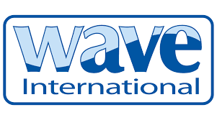
PRESS RELEASE

MHO-Co launches innovative 35m hybrid offshore support vessels with ocean protection top of agenda

Transporting crew and equipment safely to and from offshore locations in the middle of the North Sea means MHO-Co relies on the total reliability of its fleet of offshore support vessels and crew transfer vessels. Now the company has also factored in a deep-rooted regard for the environment, with the introduction of its new 35m hybrid vessels using innovative green technology.
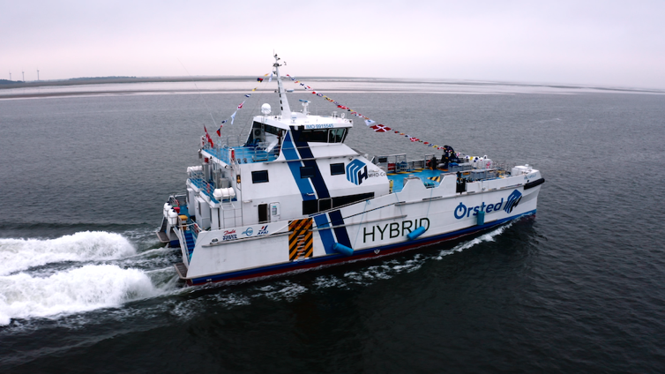
Launched in March and April 2021 and built by AFAI Southern Shipyard in Guangzhou, China these two new 35m hybrid craft - MHO Apollo and MHO Asgard - were designed by MHO’s CEO Mik Henriksen. Their modern electric motors save on weight, space and emissions. In additional each craft was specified to use the Wave MiniBOSS IMO bilge filter system which ensure that no traces of oily bilge water are emitted whilst undertaking operations at sea.

Mik Henriksen from MHO said “We looked at every element of the new hybrid catamarans to ensure that they met the highest levels of environmental protection and weight restrictions. Using the Wave MiniBOSS IMO (International Maritime Organisation) bilge filters ensures that no pollution is discharged overboard. It’s a fully automated system, which is lightweight and easy to install, and requires very little maintenance.”

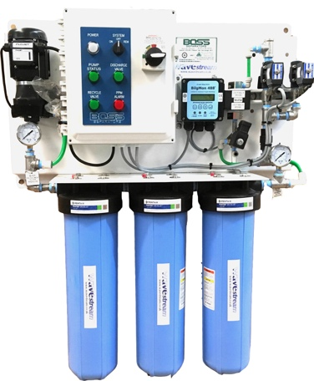
Paul Gullett, managing director of Wave International says, “We’re delighted that MHO specified Wave MiniBOSS for its new green hybrid catamarans. These vessels operate to the highest standards in terms of protecting the environment, and we’re delighted to be supporting them with Wave’s compact and reliable bilge water filtration system.”

Mik Henriksen from MHO says, “The fact that Wave products are fully approved by the US Coastguard and ABS, a leading provider of classification and technical services to the marine and offshore industries to MEPC 107 (49) means we know they will be long lasting and reliable, even in the harshest environments. Our goal is to operate and maintain our vessels to be available to clients 365 days a year, the most operating days per year in the industry, and our craft can operate even when wave heights exceed two metres.”

In addition to crew transfer and operational support vessels, many cruise ships, superyachts, military and navy vessels, commercial ships and workboats choose to protect the marine environment by using Wavestream bilge filter separators. Wave International has a worldwide network of representatives, providing sales, support and replacement parts.

More information about Wave International products, this press release and high res images can be found at www.waveinternational.co.uk For more information contact Alice Driscoll, Consulting Partners, Tel +44 (0) 7971 019377 or email alice@consultingpartners.co.uk or Paul Gullett, Wave International, info@waveinternational.co.uk

March 2022 PR155

